For the final phase of the project, you can either follow the instructions to recreate the report shown below, or design your own version -- the choice is yours!

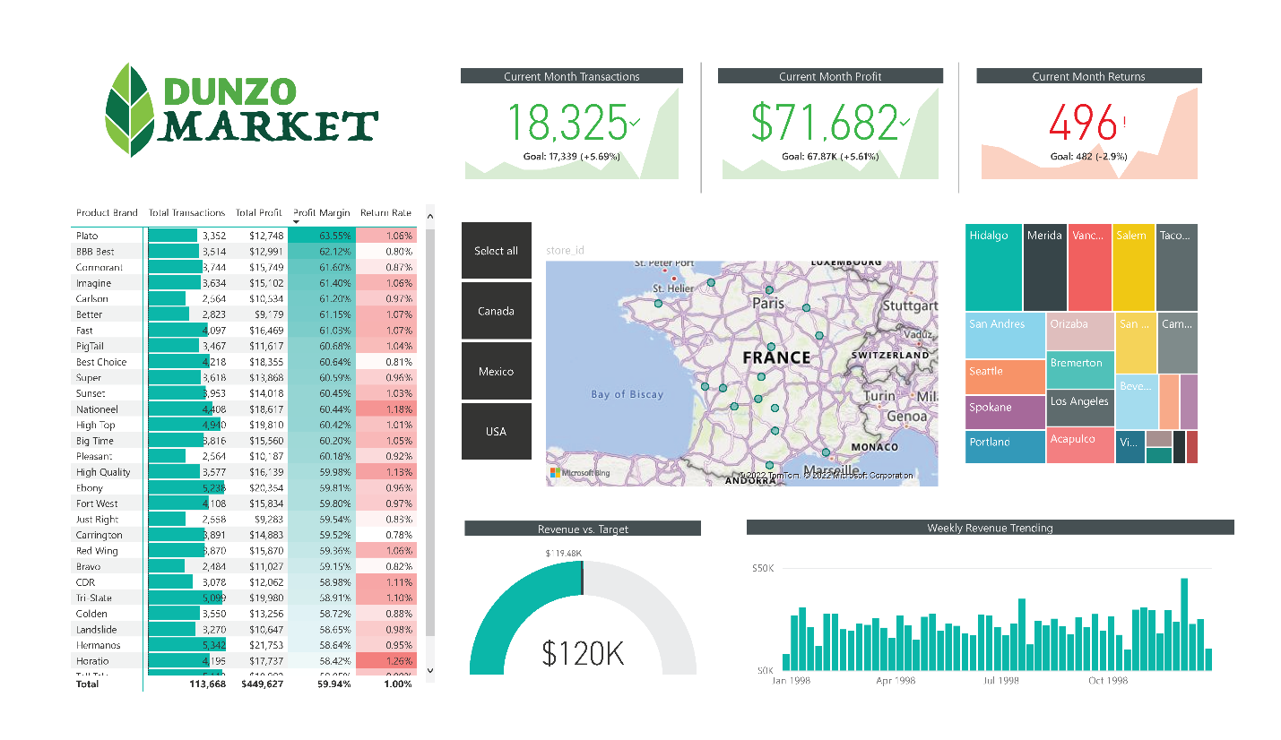

1) Rename the tab "Topline Performance" and insert the Dunzo Market logo

2) Insert a Matrix visual to show Total Transactions, Total Profit, Profit Margin, and Return Rate by Product_Brand (on rows)
- Add conditional formatting to show data bars on the Total Transactions column, and color scales on Profit Margin (White to Green) and Return Rate (White to Red)
- Add a visual level Top N filter to only show the top 30 product brands, then sort descending by Total Transactions

3) Add a KPI Card to show Total Transactions, with Start of Month as the trend axis and Last Month Transactions as the target goal
- Update the title to "Current Month Transactions", and format as you see fit
- Create two more copies: one for Total Profit (vs. Last month Profit) and one for Total Returns (vs. Last Month Returns)
  - Make sure to update titles, and change the Returns chart to color coding to "Low is Good"

4) Add a Map visual to show Total Transactions by store city
- Add a slicer for store country
  - Under the "selection controls" menu in the formatting pane, activate the "Show Select All" option
  - Pro Tip: Change the orientation in the "General" formatting menu to horizontal and resize to create a vertical stack (rather than a list)

5) Next to the map, add a Treemap visual to break down Total Transactions by store country
- Pull in store_state and store_city beneath store_country in the "Group" field to enable drill-up and drill-down functionality

6) Beneath the map, add a Column Chart to show Total Revenue by week, and format as you see fit
- Add a report level filter to only show data for 1998
- Update the title to "Weekly Revenue Trending"

7) In the lower right, add a Gauge Chart to show Total Revenue against Revenue Target (as either "target value" or "maximum value")
- Add a visual level Top N filter to show the latest Start of Month
- Remove data labels, and update the title to "Revenue vs. Target"

8) Select the Matrix and activate the Edit interactions option to prevent the Treemap from filtering

9) Select "USA" in the country slicer, and drill down to select "Portland" in the Treemap
- Add a new bookmark named "Portland 1000 Sales"
- Add a new report page, named "Notes"
- Insert a text box and write something along the lines of "Portland hits 1,000 sales in December"
- Add a button (your choice) and use the "Action" properties to link it to the bookmark you created
- Test the bookmark by CTRL-clicking the button
- Find 2-3 additional insights from the Topline Performance tab and add new bookmarks and notes linking back

10) Get creative! Practice creating new visuals, pages, or bookmarks to continue exploring the data!

